

LAB EXPERIMENT RECORD

SET 18

Department | Artificial Intelligence and Data Science
Course Code / Course Name | DSA0601 / Data Handling and Visualization
Name / Register Number | ROHAN P T / 192424112
Date / Day | 10/10/2026

Aim
To analyze product inventory management using the requested visualizations and dashboard views.

Dataset
Product Inventory Management
Product_ID | Product_Name | Quantity_Available | Price | Product_Category
1 | Product A | 250 | 20 | Electronics
2 | Product B | 175 | 15 | Home
3 | Product C | 300 | 18 | Electronics

R Data Setup
Run this setup once before the R programs below. The dataset is defined inline so each record can be copied and run without a separate CSV file.
R data setup
dat <- data.frame(
Product_ID = c(1, 2, 3),
Product_Name = c("Product A", "Product B", "Product C"),
Quantity_Available = c(250, 175, 300),
Price = c(20, 15, 18),
Product_Category = c("Electronics", "Home", "Electronics")
)

PROGRAM 1: Inventory Quantity by Product
Create a labeled bar chart of quantity available for each product.
R code
barplot(dat$Quantity_Available, names.arg=dat$Product_Name, col="skyblue3", xlab="Product", ylab="Quantity", main="Inventory Quantity by Product")

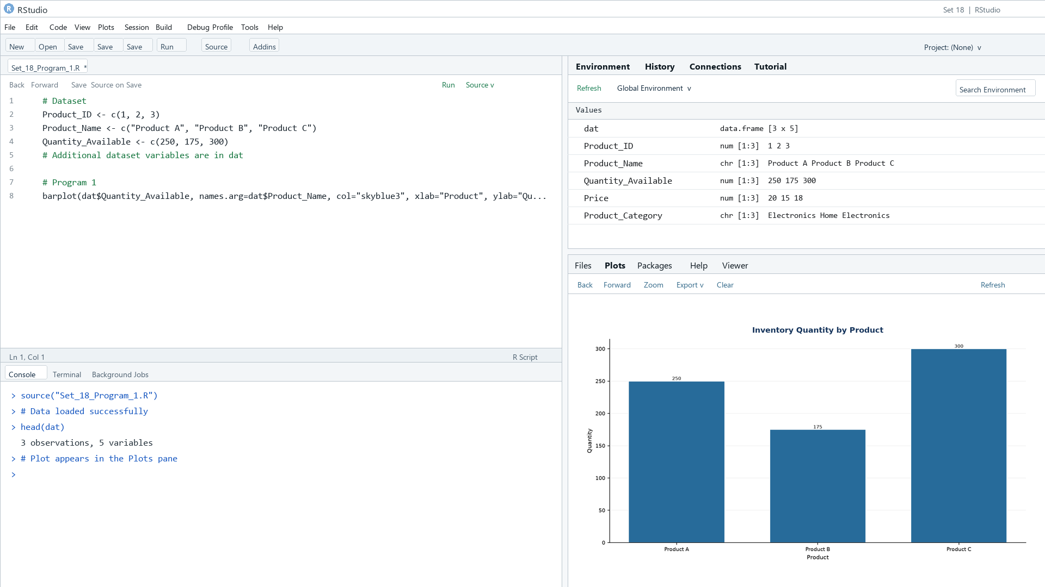
Output 1: Inventory Quantity by Product
Observation: Product C has the highest available quantity (300); Product B has the lowest (175).

PROGRAM 2: Stacked Inventory by Category
Create a stacked bar chart showing the product quantities within categories.
R code
library(ggplot2)
ggplot(dat, aes(x=Product_Category, y=Quantity_Available, fill=Product_Name)) + geom_col() + labs(title="Quantity by Product Category", x="Category", y="Quantity") + theme_minimal()

Data note: Category labels are illustrative because the source table does not include product categories.
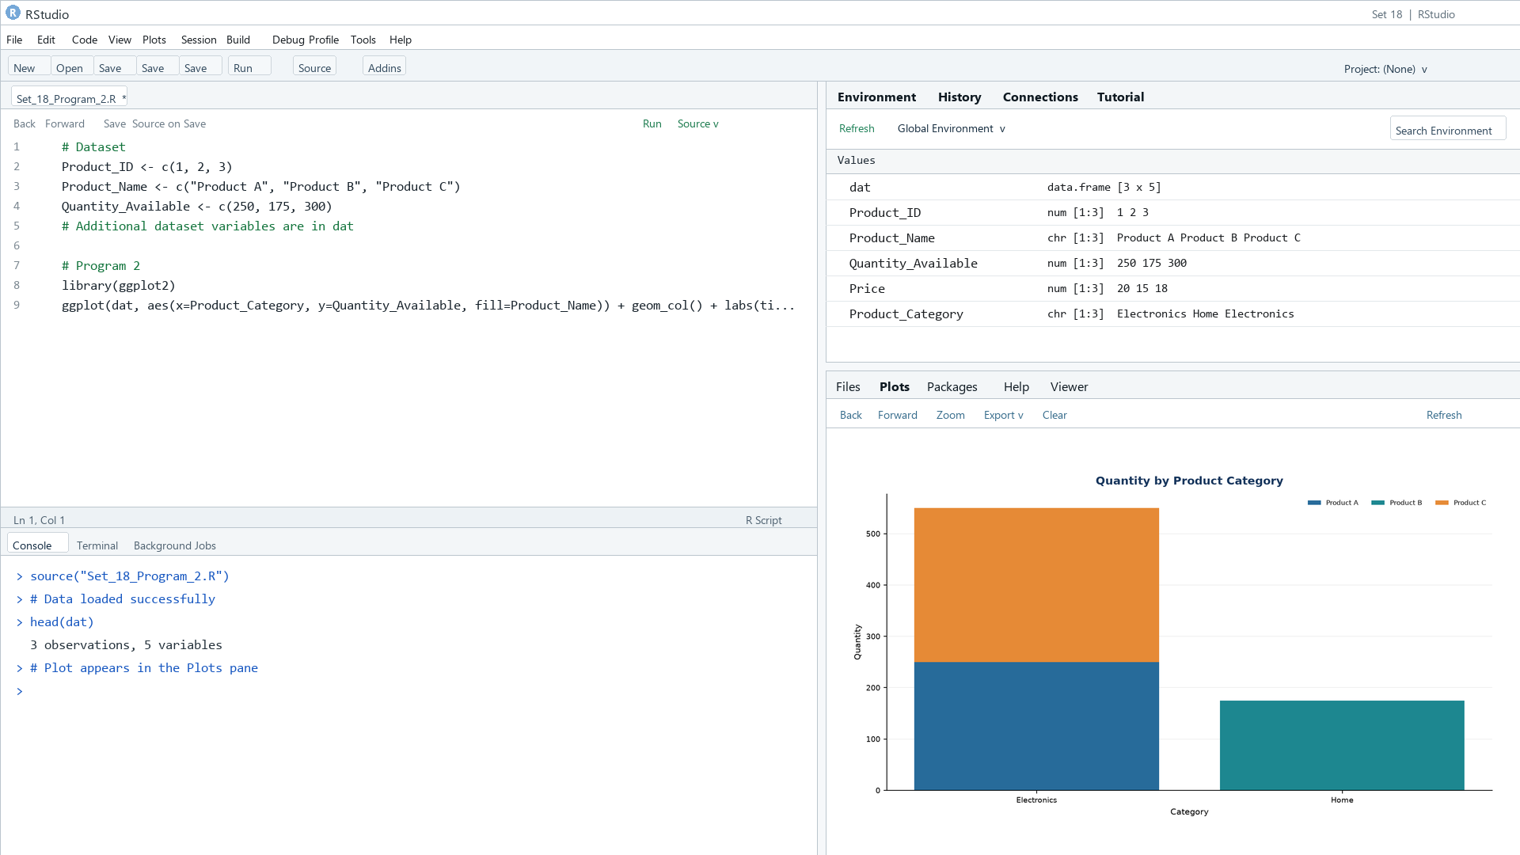
Output 2: Stacked Inventory by Category
Observation: The two illustrative categories show Electronics with 550 units and Home with 175 units.

PROGRAM 3: Product Inventory Dashboard
Build a Tableau dashboard combining the quantity bar chart, category stacked chart, and inventory table.
Tableau build steps
Tableau dashboard build
1. Connect to the inventory table.
2. Create a bar chart using Product_Name and Quantity_Available.
3. Stack Product_Name within Product_Category using SUM(Quantity_Available).
4. Add a text table and place all sheets on a dashboard.

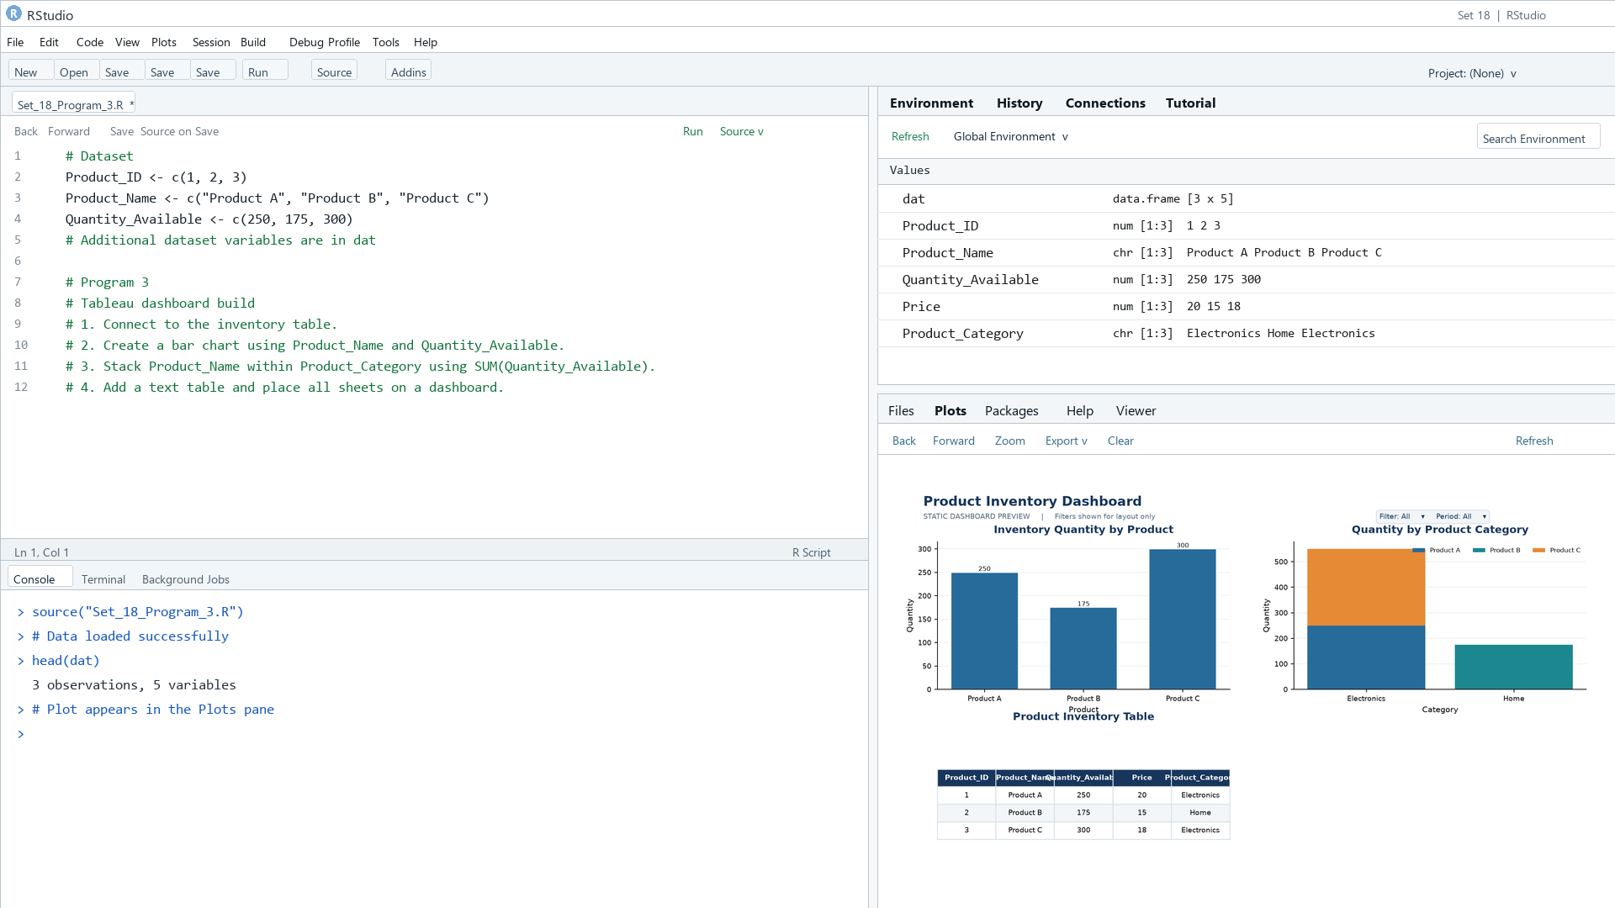
Output 3: Product Inventory Dashboard
Observation: The preview combines product quantity, category composition, and the inventory data table.

PROGRAM 4: Price and Inventory Scatter Plot
Create a scatter plot of product price versus quantity and explain the pattern.
R code
plot(dat$Price, dat$Quantity_Available, pch=19, col="#276B9A", xlab="Price ($)", ylab="Quantity", main="Price vs Quantity Available")

Data note: Prices are illustrative because the source lists quantities only.
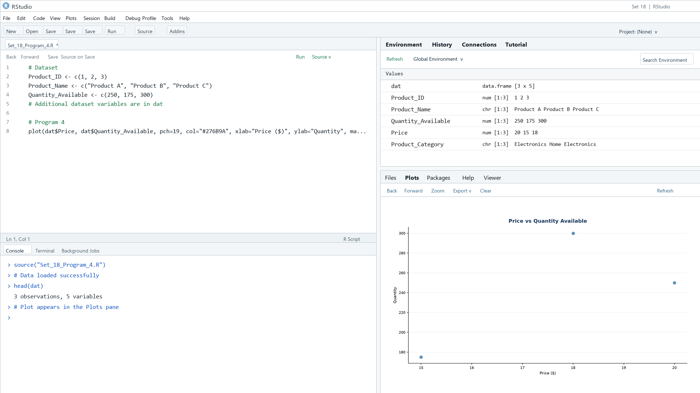
Output 4: Price and Inventory Scatter Plot
Observation: The three illustrative records do not show a clear price-quantity relationship.

Procedure
1. Review the dataset table and confirm any illustrative fields noted in the record.
2. Run the R setup block once, then run the requested program code.
3. Compare the output screenshot with the observation and replace illustrative values when actual data is available.
4. For Tableau tasks, connect to the displayed data and follow the dashboard build steps.

Result
The requested charts and dashboard views for Set 18 were prepared from the displayed dataset. Outputs include labels, short observations, and code or dashboard construction steps.

Key Functions Used
plot(), barplot(), hist(), boxplot(), table().

